**Phase 2: Salesforce Org Setup & Configuration**

**App name- “Ecommerce after sales”**

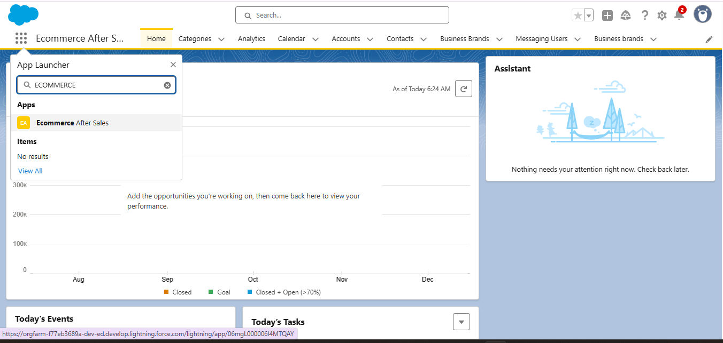



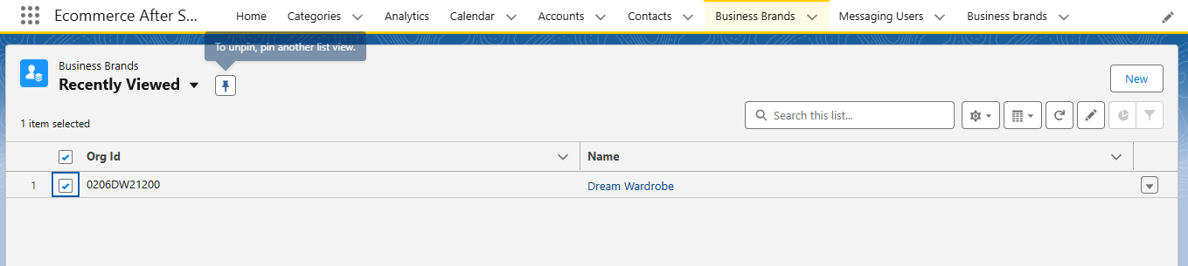

**Name- Shubhangi Vishwakarma**

**College- Gyan Ganga Institute of Technology & Sciences Jabalpur**

**Phase 2 SmartBridge Salesforce trainee**